
LEARNER GUIDE
Certified Lean Six Sigma White Belt (CLSSWB) Training
TGS Ref No: TGS-2025053210
Conducted by Tertiary Infotech Academy Pte Ltd
UEN: 201200696W
Version 1.0

Document Version Control Record
Version | Effective Date | Summary of Changes | Author
1.0 | 9 July 2026 | First courseware release aligned to the eight CLSSWB labs | Tertiary Infotech Academy Pte Ltd

Course Overview
This learner guide supports a practical White Belt course for learners who are new to Lean Six Sigma. The guide mirrors the lab sequence and provides step-by-step guidance for building a simple improvement portfolio.
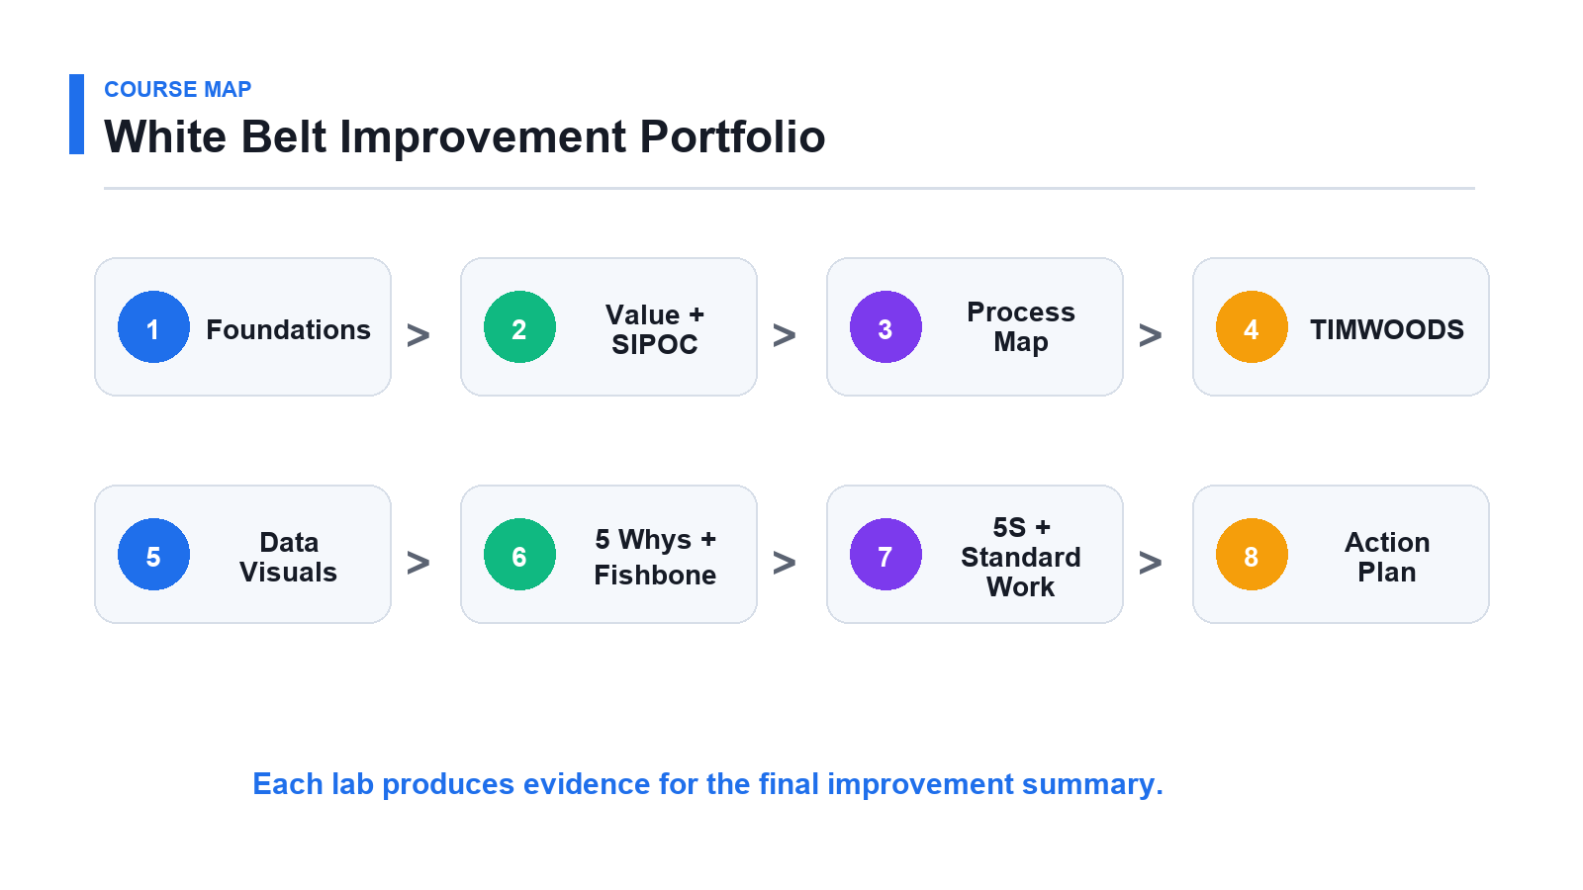
Visual roadmap: each lab adds one piece to the White Belt improvement portfolio.

Learning Outcomes
- Explain Lean, Six Sigma, DMAIC, and the White Belt role in plain language.
- Identify customer value, non-value-added work, handoffs, waiting, and TIMWOODS waste.
- Create a simple SIPOC, process map, check sheet, chart, 5 Whys, Fishbone, 5S action list, standard work draft, and improvement action plan.
- Summarize a small improvement opportunity respectfully and with evidence.
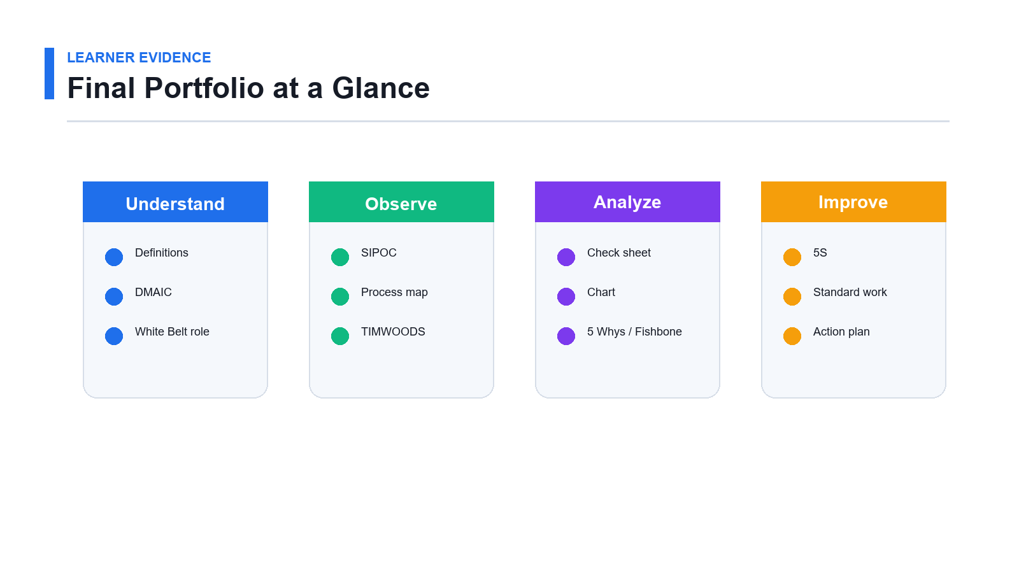
Portfolio evidence: keep outputs organized as you move through the labs.

Before You Start
- Choose one simple workplace or daily process that is safe to discuss.
- Create a portfolio folder for all lab outputs.
- Record facts separately from opinions and assumptions.
- Escalate sensitive, complex, or high-risk issues to the appropriate owner.

Lab 1: Lean Six Sigma Foundations

Objectives
- Explain Lean and Six Sigma in plain language.
- Describe DMAIC.
- Understand the White Belt support role.
- Select a simple process for the course.

Scenario
You are new to Lean Six Sigma and have been asked to support improvement activity in your team. Your first task is to understand the basic language and choose a simple process to observe.
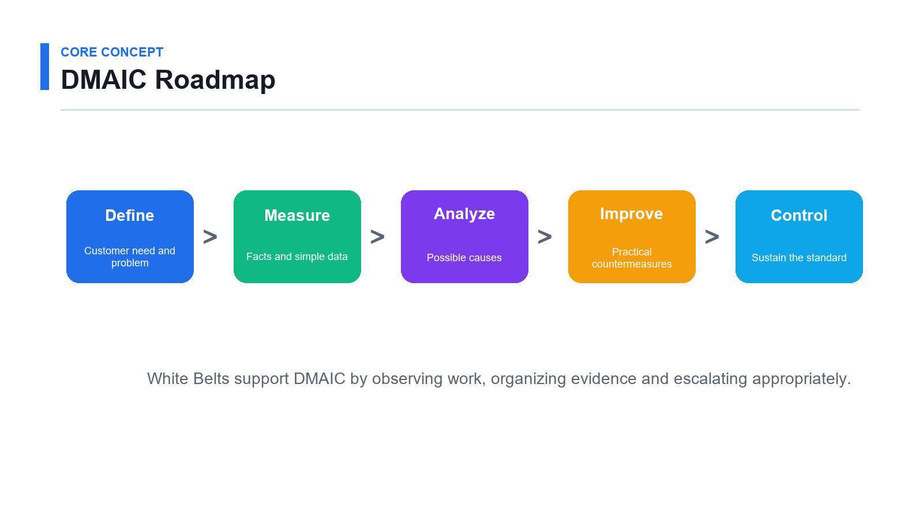
Lab 1 visual guide: Lean Six Sigma Foundations.

Step-by-Step Guide
- Write a one-sentence definition of Lean. Record this in your lab journal.
- Write a one-sentence definition of Six Sigma. Use the same process example where possible.
- List the five DMAIC phases. Keep the wording simple and observable.
- Write one simple example activity for each DMAIC phase. Check the output with a peer or trainer.
- List three ways a White Belt can support an improvement project. Save the evidence in your portfolio folder.
- List two situations that should be escalated to a Green Belt, Black Belt, manager, or process owner. Record this in your lab journal.
- Choose one simple workplace process. Use the same process example where possible.
- Write why the process matters to customers, learners, staff, or the business. Keep the wording simple and observable.
- Write one problem you have seen in the process. Check the output with a peer or trainer.
- Share your process example with another learner. Save the evidence in your portfolio folder.

Validation Checks
- Your Lean and Six Sigma definitions are understandable.
- You can explain DMAIC without reading from notes.
- Your selected process is simple enough to observe.
- You know the limits of the White Belt role.

Deliverables
- Lean and Six Sigma definitions.
- DMAIC summary.
- White Belt role notes.
- Selected process example.

Review Questions
- What is the main focus of Lean?
- What is the main focus of Six Sigma?
- Why is DMAIC useful?
- Why are White Belts important even if they do not lead projects?

Lab 2: Customer Value and Process Thinking

Objectives
- Identify process customers.
- Define customer value.
- Build a simple SIPOC.
- Identify value-added and non-value-added activity.

Scenario
A process exists to deliver value to someone. You will identify the customer, what they need, and the process boundary before looking for waste.
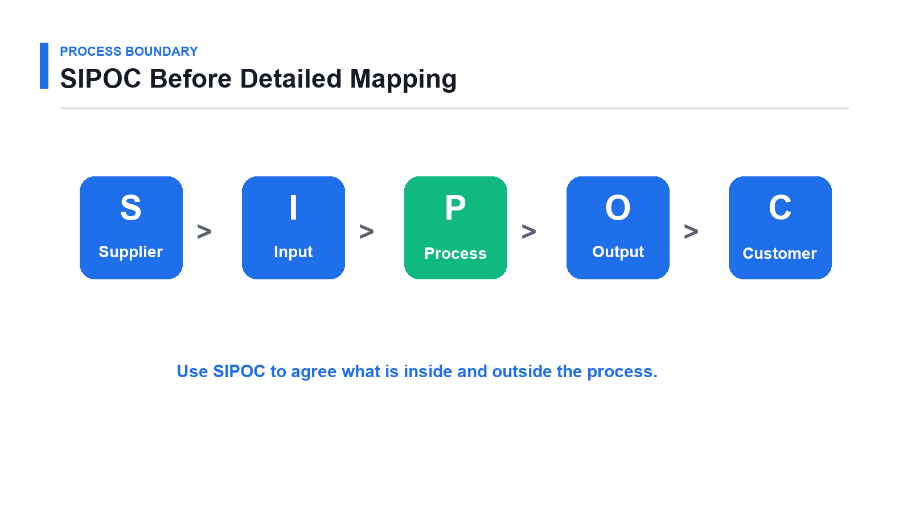
Lab 2 visual guide: Customer Value and Process Thinking.

Step-by-Step Guide
- Write the name of your selected process. Record this in your lab journal.
- Identify the customer or receiver of the process output. Use the same process example where possible.
- Write what the customer needs from the process. Keep the wording simple and observable.
- Define the process start point. Check the output with a peer or trainer.
- Define the process end point. Save the evidence in your portfolio folder.
- List suppliers. Record this in your lab journal.
- List inputs. Use the same process example where possible.
- List 5 to 7 major process steps. Keep the wording simple and observable.
- List outputs. Check the output with a peer or trainer.
- List customers. Save the evidence in your portfolio folder.
- Create a simple SIPOC table. Record this in your lab journal.
- Mark each major step as value-added, business-required, or non-value-added. Use the same process example where possible.
- Circle one step that looks slow, unclear, repeated, or error-prone. Keep the wording simple and observable.

Validation Checks
- The customer is clearly identified.
- SIPOC has a clear start and end boundary.
- Activity labels are based on customer value.
- One improvement opportunity is identified.

Deliverables
- Customer value worksheet.
- Simple SIPOC.
- Value-added activity list.
- Improvement opportunity note.

Review Questions
- Why should improvement start with the customer?
- What is value-added work?
- Why might business-required work not be customer value-added?
- How does SIPOC help scope a process?

Lab 3: Process Walk and Simple Map

Objectives
- Observe a process respectfully.
- Record actual work steps.
- Draw a simple process map.
- Identify handoffs and waiting.

Scenario
Processes often work differently from how people describe them. You will observe the real workflow and map what actually happens.
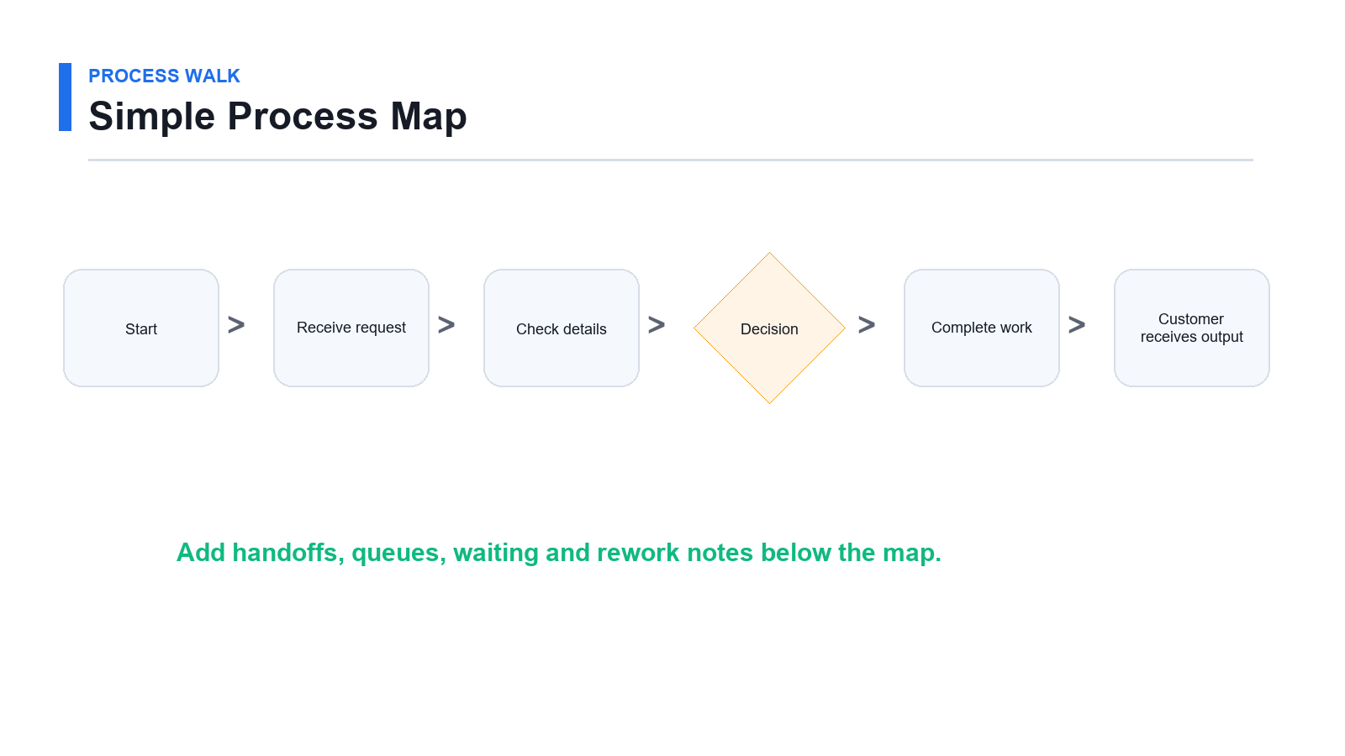
Lab 3 visual guide: Process Walk and Simple Map.

Step-by-Step Guide
- Review the process from Lab 02. Record this in your lab journal.
- Visit the place where work happens or interview someone who performs the work. Use the same process example where possible.
- Observe without blaming, interrupting, or correcting people. Keep the wording simple and observable.
- Record the actual steps in order. Check the output with a peer or trainer.
- Record who performs each step. Save the evidence in your portfolio folder.
- Note handoffs between people, teams, tools, or systems. Record this in your lab journal.
- Note waiting points. Use the same process example where possible.
- Note rework, repeated checking, or unclear decisions. Keep the wording simple and observable.
- Draw a simple flowchart using boxes and arrows. Check the output with a peer or trainer.
- Add decision diamonds where the process branches. Save the evidence in your portfolio folder.
- Mark one process step that should be discussed with the process owner. Record this in your lab journal.
- Ask another learner whether your map is easy to follow. Use the same process example where possible.

Validation Checks
- The map follows the actual process sequence.
- Handoffs and waits are visible.
- Observations are factual and respectful.
- The map can be understood by someone outside the process.

Deliverables
- Process walk notes.
- Simple process map.
- Handoff and waiting notes.
- Process owner discussion point.

Review Questions
- What is the value of observing work directly?
- Why should process walks avoid blame?
- How can handoffs create problems?
- What makes a process map useful?

Lab 4: Identify TIMWOODS Waste

Objectives
- Recognize the eight wastes.
- Find waste in a simple process.
- Link waste to customer impact.
- Prioritize one waste area.

Scenario
Lean improvement starts with seeing waste. You will review your process map and identify where time, effort, information, or talent is being wasted.
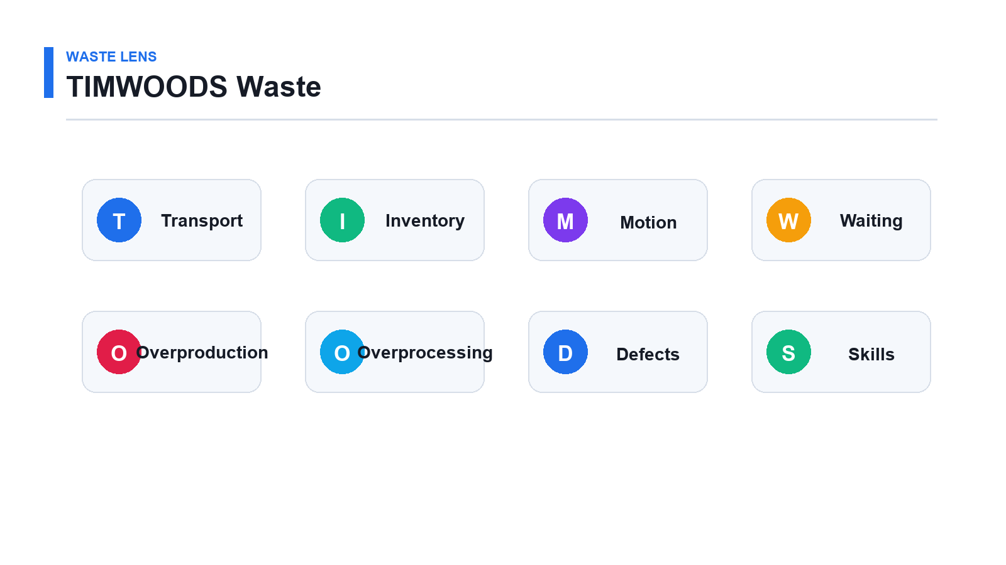
Lab 4 visual guide: Identify TIMWOODS Waste.

Step-by-Step Guide
- Review TIMWOODS: Record this in your lab journal.
- Transport. Use the same process example where possible.
- Inventory. Keep the wording simple and observable.
- Motion. Check the output with a peer or trainer.
- Waiting. Save the evidence in your portfolio folder.
- Overproduction. Record this in your lab journal.
- Overprocessing. Use the same process example where possible.
- Defects. Keep the wording simple and observable.
- Skills. Check the output with a peer or trainer.
- Open the process map from Lab 03. Save the evidence in your portfolio folder.
- Review each process step one by one. Record this in your lab journal.
- Mark examples of unnecessary movement of items or information. Use the same process example where possible.
- Mark queues, backlog, or work-in-progress. Keep the wording simple and observable.
- Mark unnecessary movement by people. Check the output with a peer or trainer.
- Mark waiting time. Save the evidence in your portfolio folder.
- Mark work done too early or in too much quantity. Record this in your lab journal.
- Mark extra checking or repeated entry. Use the same process example where possible.
- Mark errors, rework, missing information, or corrections. Keep the wording simple and observable.
- Mark places where people's ideas or skills are not used. Check the output with a peer or trainer.
- Choose the one waste area with the largest visible impact. Save the evidence in your portfolio folder.

Validation Checks
- Waste examples are tied to specific process steps.
- The priority waste has a clear customer or business impact.
- Observations are specific enough for discussion.
- The team avoids blaming individuals.

Deliverables
- TIMWOODS waste table.
- Marked process map.
- Priority waste statement.
- One improvement question.

Review Questions
- Which waste is easiest to see in your process?
- Which waste is easiest to overlook?
- How can defects create other wastes?
- Why is underused skill a waste?

Lab 5: Basic Data and Visuals

Objectives
- Create a basic check sheet.
- Count issue categories.
- Build a simple visual.
- Use data to focus discussion.

Scenario
Improvement should not rely only on opinion. You will collect a small amount of simple data and use it to identify what to discuss first.
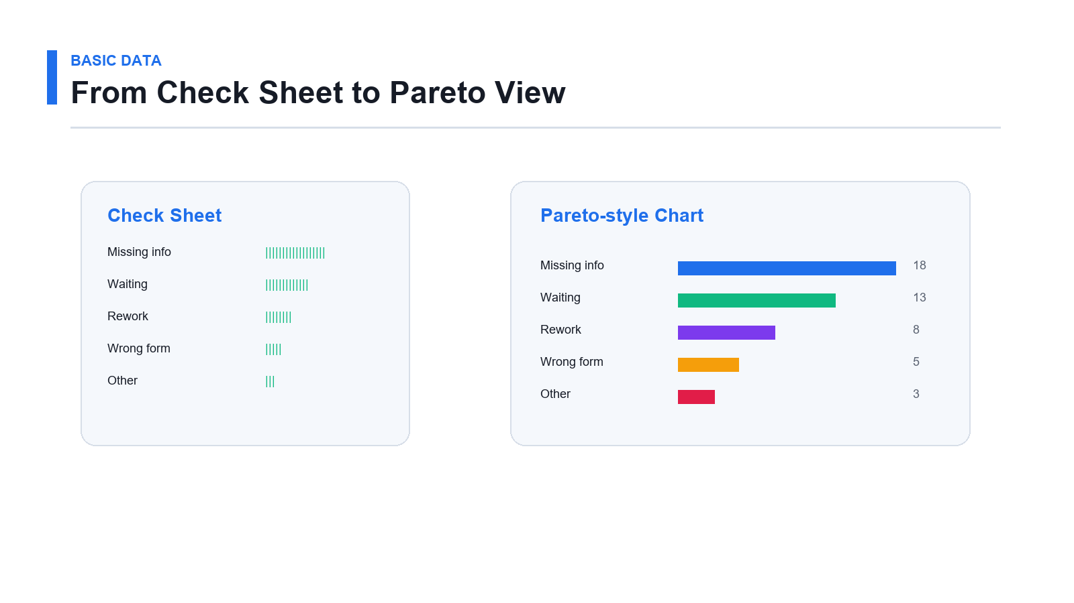
Lab 5 visual guide: Basic Data and Visuals.

Step-by-Step Guide
- Choose one issue or waste area from Lab 04. Record this in your lab journal.
- Decide what can be counted safely. Use the same process example where possible.
- Define clear categories. Keep the wording simple and observable.
- Create a check sheet with category names and tally marks. Check the output with a peer or trainer.
- Collect sample data or use a trainer-provided dataset. Save the evidence in your portfolio folder.
- Add the tally marks. Record this in your lab journal.
- Calculate category totals. Use the same process example where possible.
- Calculate total observations. Keep the wording simple and observable.
- Create a bar chart. Check the output with a peer or trainer.
- Sort the chart from largest category to smallest category. Save the evidence in your portfolio folder.
- Create a run chart if the data includes dates or times. Record this in your lab journal.
- Write one sentence explaining what the visual shows. Use the same process example where possible.
- Write one question that should be investigated. Keep the wording simple and observable.

Validation Checks
- Categories are clear and not overlapping.
- Counts are added correctly.
- The chart has a title and labels.
- The conclusion is based on the data shown.

Deliverables
- Check sheet.
- Tally table.
- Bar chart or Pareto-style chart.
- Run chart if time data is available.
- Data observation note.

Review Questions
- Why is a check sheet useful?
- Why should categories be clearly defined?
- What does a sorted bar chart help you see?
- How can simple data improve team discussion?

Lab 6: Problem Solving with 5 Whys and Fishbone

Objectives
- Write a fact-based problem statement.
- Use 5 Whys.
- Build a Fishbone diagram.
- Identify evidence needed before action.

Scenario
The team has identified a visible issue. Before suggesting solutions, you will explore possible causes in a structured and respectful way.
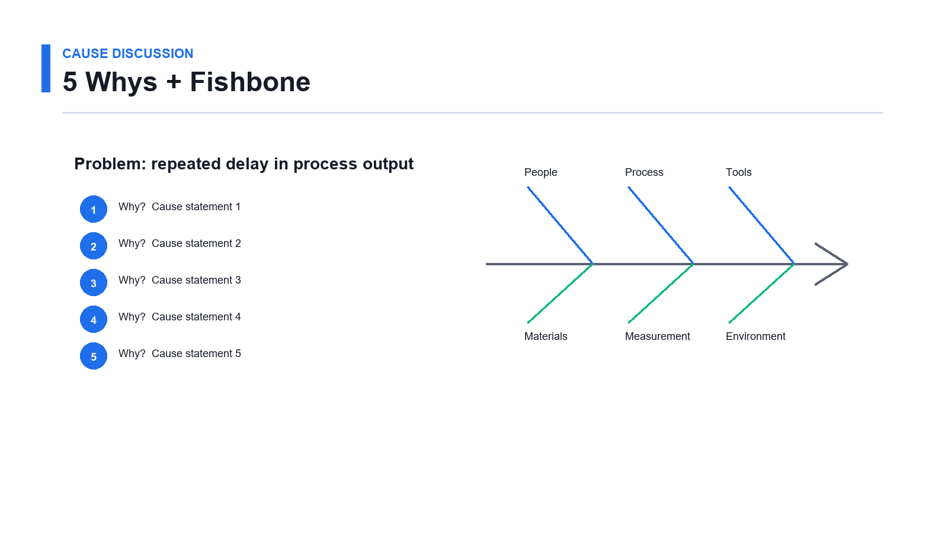
Lab 6 visual guide: Problem Solving with 5 Whys and Fishbone.

Step-by-Step Guide
- Select the issue from Lab 05. Record this in your lab journal.
- Write a problem statement using facts from the process or data. Use the same process example where possible.
- Ask why the problem happens. Keep the wording simple and observable.
- Continue asking why until you reach a process-related possible cause. Check the output with a peer or trainer.
- Avoid blaming a person as the final cause. Save the evidence in your portfolio folder.
- Create a Fishbone diagram. Record this in your lab journal.
- Use categories such as people, process, tools, materials, measurement, and environment. Use the same process example where possible.
- Add possible causes to each category. Keep the wording simple and observable.
- Circle two causes that seem most likely. Check the output with a peer or trainer.
- Write what evidence would support or reject each cause. Save the evidence in your portfolio folder.
- Identify who can help confirm the cause. Record this in your lab journal.
- Write one safe next investigation step. Use the same process example where possible.

Validation Checks
- The problem statement is factual.
- The 5 Whys chain does not stop at blame.
- Fishbone causes are plausible.
- Evidence needed is clearly listed.

Deliverables
- Problem statement.
- 5 Whys worksheet.
- Fishbone diagram.
- Evidence-needed list.
- Next investigation step.

Review Questions
- Why should teams avoid jumping straight to solutions?
- Why is blame weak root cause analysis?
- How does Fishbone thinking help a team?
- What is the difference between a possible cause and a proven cause?

Lab 7: 5S, Standard Work, and Visual Controls

Objectives
- Apply 5S thinking.
- Identify visual control opportunities.
- Draft simple standard work.
- Support sustainment.

Scenario
Small improvements are easier to sustain when the workplace is organized, the standard is clear, and the team can see when something is not normal.
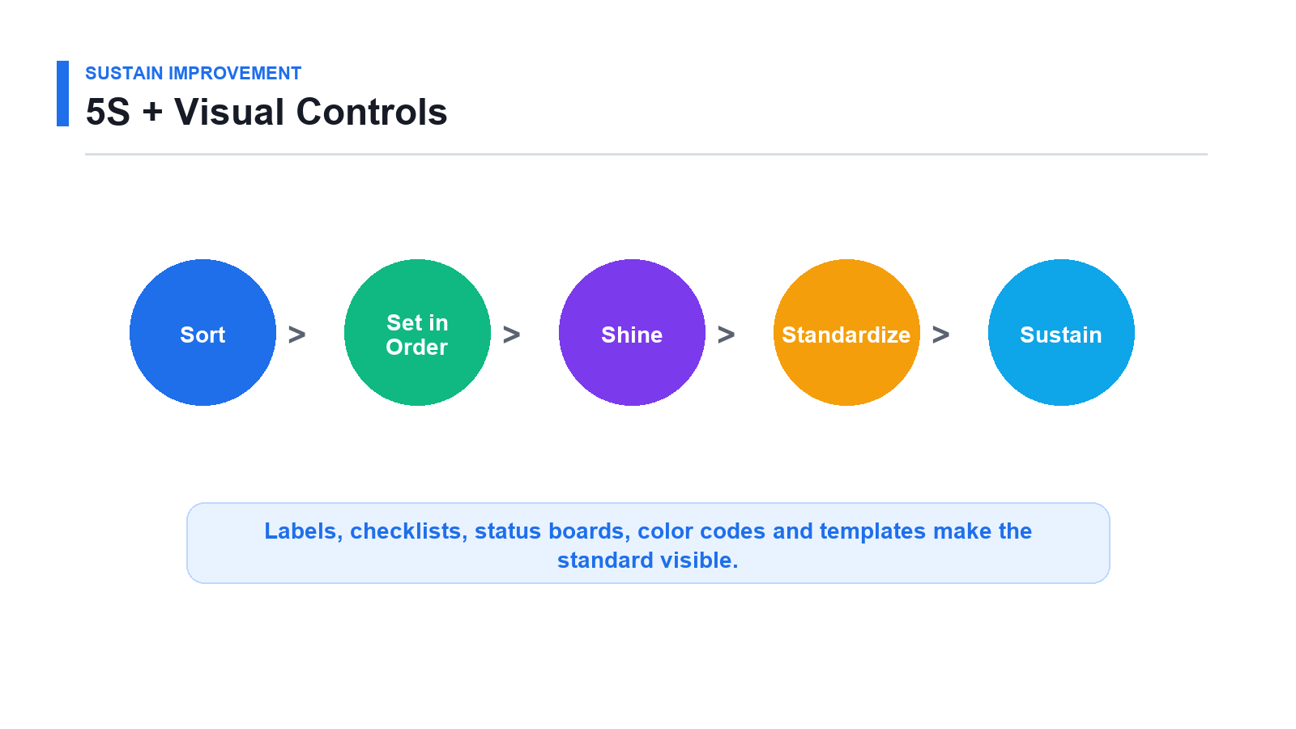
Lab 7 visual guide: 5S, Standard Work, and Visual Controls.

Step-by-Step Guide
- Choose one physical workspace, digital folder, form, queue, or process step. Record this in your lab journal.
- Apply Sort: list what is needed and not needed. Use the same process example where possible.
- Apply Set in Order: decide where needed items or information should be located. Keep the wording simple and observable.
- Apply Shine: identify what should be cleaned, corrected, clarified, or updated. Check the output with a peer or trainer.
- Apply Standardize: define what good looks like. Save the evidence in your portfolio folder.
- Apply Sustain: define how the standard will be checked. Record this in your lab journal.
- Identify where a label, checklist, color code, status board, or template would help. Use the same process example where possible.
- Draft a short standard work instruction. Keep the wording simple and observable.
- Include task name, steps, expected result, and check method. Check the output with a peer or trainer.
- Ask a partner to review whether the instruction is clear. Save the evidence in your portfolio folder.
- Revise the standard work based on feedback. Record this in your lab journal.

Validation Checks
- The 5S actions are practical.
- The visual control makes abnormal conditions easier to see.
- Standard work is written simply.
- Another learner can follow the instruction.

Deliverables
- 5S action list.
- Visual control idea.
- Draft standard work.
- Feedback notes.

Review Questions
- What does 5S help prevent?
- Why are visual controls useful?
- What makes standard work easy to follow?
- How does sustainment differ from a one-time cleanup?

Lab 8: Improvement Summary and Action Plan

Objectives
- Summarize the improvement opportunity.
- Create a simple action plan.
- Identify who should be involved next.
- Present a White Belt improvement story.

Scenario
You have observed a process, identified waste, collected simple data, and explored possible causes. You will now summarize the opportunity and prepare a practical next step.
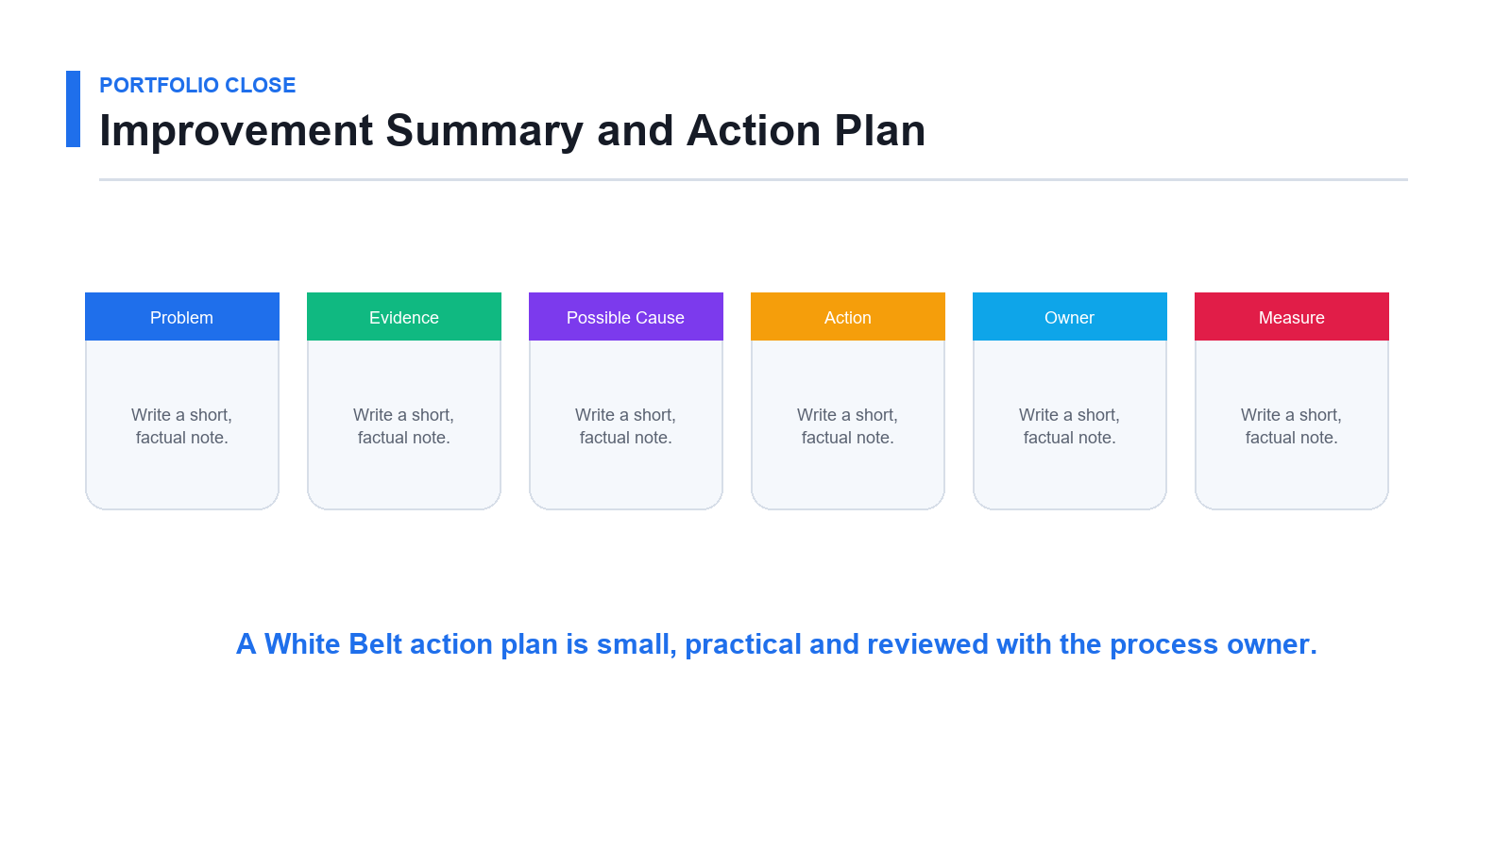
Lab 8 visual guide: Improvement Summary and Action Plan.

Step-by-Step Guide
- Review all lab worksheets. Record this in your lab journal.
- Write the process name. Use the same process example where possible.
- Identify the customer. Keep the wording simple and observable.
- Summarize the problem in one sentence. Check the output with a peer or trainer.
- Summarize the waste observed. Save the evidence in your portfolio folder.
- Summarize the simple data collected. Record this in your lab journal.
- Summarize the possible cause. Use the same process example where possible.
- Write one practical improvement idea. Keep the wording simple and observable.
- Identify the process owner or team that should review the idea. Check the output with a peer or trainer.
- Define the first action. Save the evidence in your portfolio folder.
- Assign an owner or recommended owner. Record this in your lab journal.
- Set a due date or review date. Use the same process example where possible.
- Define how the team will know whether the change helped. Keep the wording simple and observable.
- Prepare a three-minute presentation. Check the output with a peer or trainer.
- Present to a peer or trainer and record feedback. Save the evidence in your portfolio folder.

Validation Checks
- The summary uses evidence from previous labs.
- The action plan has owner, date, and measure.
- The proposed improvement is small and realistic.
- The presentation is clear and respectful.

Deliverables
- Improvement summary.
- Action plan.
- Measurement idea.
- Presentation notes.
- Lessons learned.

Review Questions
- Why should an action plan include an owner?
- Why should a change have a measure?
- What makes an improvement idea realistic?
- How can White Belts support continuous improvement after training?

Final Portfolio Checklist
- Lean and Six Sigma definitions; DMAIC summary; White Belt role notes.
- Customer value worksheet; simple SIPOC; process map.
- TIMWOODS waste table; check sheet; tally table; simple chart.
- Problem statement; 5 Whys worksheet; Fishbone diagram; evidence-needed list.
- 5S action list; visual control idea; standard work draft; improvement summary and action plan.

